*<Insert group Name>*

*<Insert Course Code/Course Name>*

**Test Design Specifications**

# 

# Document Control

|  |  |
| --- | --- |
| **Document Name** |  |
| **Reference Number** |  |
| **Version** |  |
| **Project Code** |  |
| **Status** |  |
| **Date Released** |  |

|  |  |  |
| --- | --- | --- |
| **Name** | **Position** | **Contact Number** |
| Prepared By*:* |  |  |
| Reviewed By: |  |  |

# Table of Content

Document Control i

Version History ii

Distribution List ii

Table of Content iii

1.0 Introduction 1

1.1 Purpose 1

1.2 Scope 1

1.3 References 1

2.0 Test Design 2

2.1 Features To Be Tested 2

2.2 Approach Refinements 2

2.3 Test Identification 3

2.4 Feature Pass/Fail Criteria 3

2.5 Test Deliverable 3

# 1.0 Introduction

|  |
| --- |
| 1.1 Purpose1.2 Scope |

## 1.3 References

# 2.0 Test Design

## 2.1 Features To Be Tested

<copy from test plan>

|  |  |  |
| --- | --- | --- |
| **Feature ID** | **Description** | **Risk Level (use your assumption )** |
|  |  |  |
|  |  |  |

## 2.2 Approach Refinements

2.2.1 Feature X

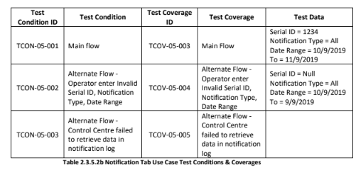

2.2.2 Feature X

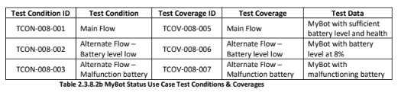

## 2.3 Test Identification

This section should contain information at least as below:

|  |  |
| --- | --- |
| **Test Case ID** | **Description** |
|  |  |

## 2.4 Feature Pass/Fail Criteria

<sample>

The feature will be considered passed by meeting the following:

·        Function works according to stated requirements.

·        Feature works correctly on test platforms.

·        Feature works correctly with other modules of application.

·        All issues with High and Medium Priority will be verified and closed.

## 2.5 Test Deliverable

i. Test Plan

ii. Test Transmittal Report

iii. Test Design Specifications

iv. Test Case Specifications

v. Test Procedure Specifications

vi. Test Logs

vii.  Test Incident Reports

viii. Test Summary Report

ix. Test Completion report